ON AUG 12 STARTING 10AM
WE CAN REMOVE ALL GEOFENCING LIMITS IMPOSED ON THE WEBSITE.
THE FINAL REIT PLAN ALSO WILL NOT NEED GEOFENCING AND
DO NOT NEED TO BE BEHIND A CLICKTHROUGH PROCEDURE ANYMORE –
ANYBODY WHO WILL CLICK THE BUTTON SHOULD BE ABLE TO ACCESS IT.

Page | Topic
2 | New Cebu VR
3 | Banner Edits
4 | Homepage Edits
6 | About Us
7 | Organizational Structure
8 | Corporate Structure
9 | Articles of Incorporation and By Laws
10 | Our Tenancy
11 | Reconfigured Menu / Tabs
12 | Company News
13 | Board Committees and Members
14 | REIT Education
15 | Contact Us
16 | Gallery

WEBSITE EDITS AS OF 08/03/2021
Take a tour – add Filinvest Cyberzone Cebu (after Northgate Cyberzone)
https://exsight360.com/virtual-tours/filinvest/filinvest-cyberzone-cebu/v2/tour.html
Add button below: Find out more about Filinvest Cyberzone Cebu (Linked to: Our Projects > Cyberzone Cebu)
**
Northgate Cyberzone VR – add also button below: Find out more about Northgate Cyberzone (Linked to: Our Projects > Northgate Cyberzone)
**
Filinvest City VR – add also button below: Find out more about Filinvest City (Linked to: www.filinvestcity.com)

Homepage Edits
- Change ‘Who We Are’ to ‘Positioned for Steady Growth’ (Have growth in orange)
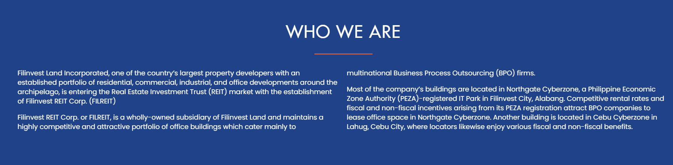
- Change text under who we are, Rewrite to:

Filinvest REIT Corp. (FILREIT) is a real estate investment trust backed by Filinvest Land, one of the largest property developers in the Philippines with an established portfolio of residential, commercial, industrial, and office developments around the archipelago.

FILREIT is a wholly owned subsidiary of Filinvest Land, maintaining a highly competitive and attractive portfolio of office buildings which cater mainly to high-growth multinational Business Process Outsourcing (BPO) firms.

FILREIT’s portfolio consists of 17 world-class, Grade A office buildings: 16 located in Northgate Cyberzone, a Philippine Economic Zone Authority (PEZA) registered IT Park in Filinvest City, Alabang, and one in Cebu Cyberzone, the gateway of Cebu IT Park in Lahug, Cebu City. All these Grade A office buildings sit on prime property of more than 300,000 square meters of gross leasable area.

- Video:
Can visitors have the option to turn the volume on?

- FILREIT Advantage
Link reputation and track record to: https://www.filinvestland.com/our-company/company-background
Link globally renowned tenants to the Our Tenancy page
Edit copy for Strong organic and inorganic growth: (315,000 sqm gross leasable area potential pipeline)
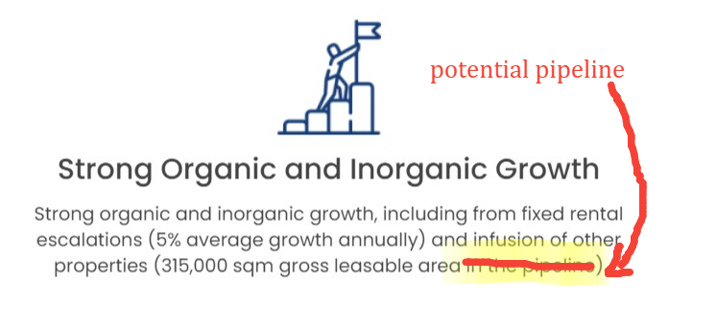
Edit copy for BPO occupied GLA: Occupied GLA leased to global BPOs
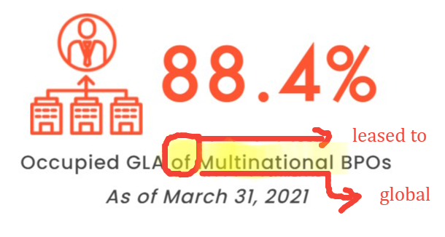

- About our portfolio: Rewrite text
Old | New
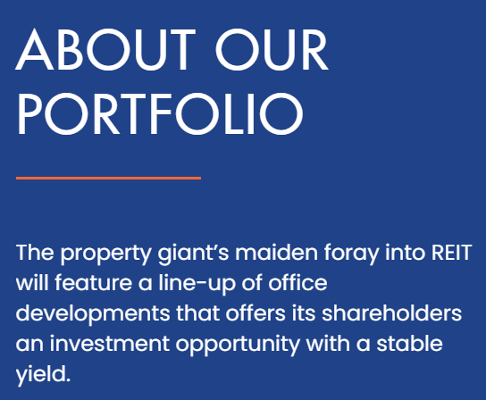 | FILREIT features a lineup of office developments that offers an investment opportunity with a stable yield.

- REIT Education: Rewrite text, add button: “Learn more”
Old | New
A real estate investment trust (REIT) is a stock corporation established for the purpose of owning income-generating real estate asserts such as apartment buildings, office buildings, hospitals, hotels, resorts, shopping centers, and more. It is a booming opportunity for the investing public.

(Button: “Learn more” -> lead to REIT education tab)

About Us https://www.filinvestreit.com/about-us

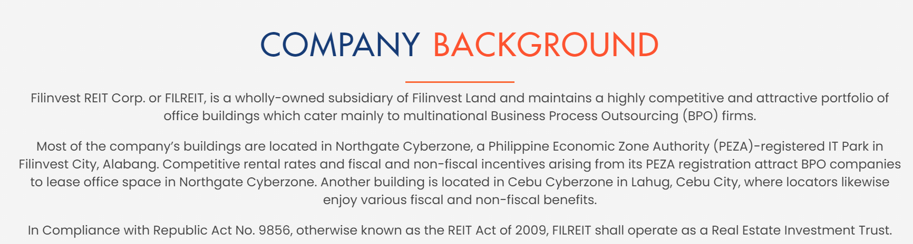
Rewrite copy to:

Filinvest REIT Corp. (FILREIT) is a real estate investment trust backed by Filinvest Land, one of the largest property developers in the Philippines with an established portfolio of residential, commercial, industrial, and office developments around the archipelago.

Formerly Cyberzone Properties. Inc., FILREIT is a wholly owned subsidiary of Filinvest Land, maintaining a highly competitive and attractive portfolio of office buildings which cater mainly to high-growth multinational Business Process Outsourcing (BPO) firms.

FILREIT’s portfolio consists of 17 office buildings: 16 located in Northgate Cyberzone, a Philippine Economic Zone Authority (PEZA) registered IT Park in Filinvest City, Alabang, and one in Cebu Cyberzone, the gateway of Cebu IT Park in Lahug, Cebu City. All these Grade A office buildings sit on prime property of more than 300,000 square meters of gross leasable area. Competitive rental rates as well as fiscal and non-fiscal benefits for locators attract BPO companies to least office space.

FILREIT operates as a Real Estate Investment Trust in compliance with Republic Act No. 9856, otherwise known as the REIT Act of 2009.

Organizational Structure
(Table is wrong)

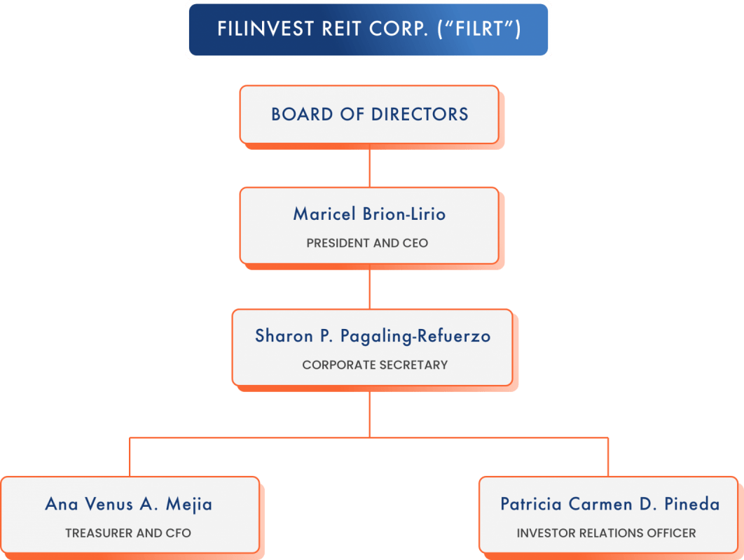

Bottom part – Sharon P. Pagaling-Refuerzo’s box should be the same level as Ana Venus Mejia and Patricia Pineda – put her in the middle

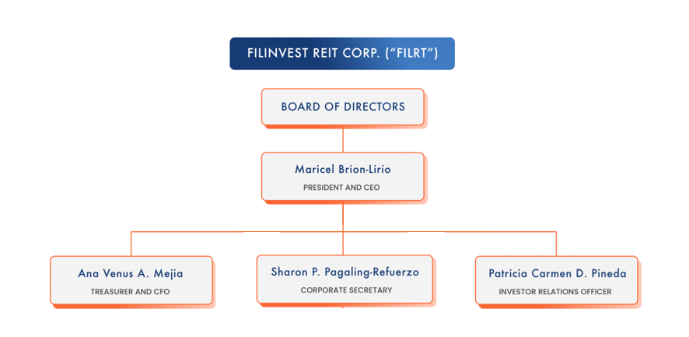

Corporate Structure
The chart is too big, can we make it a bit smaller
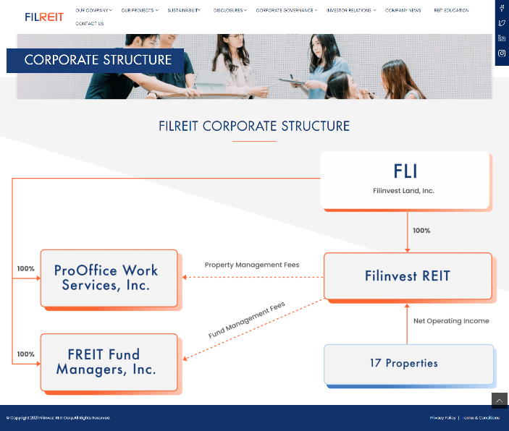

Something like this:
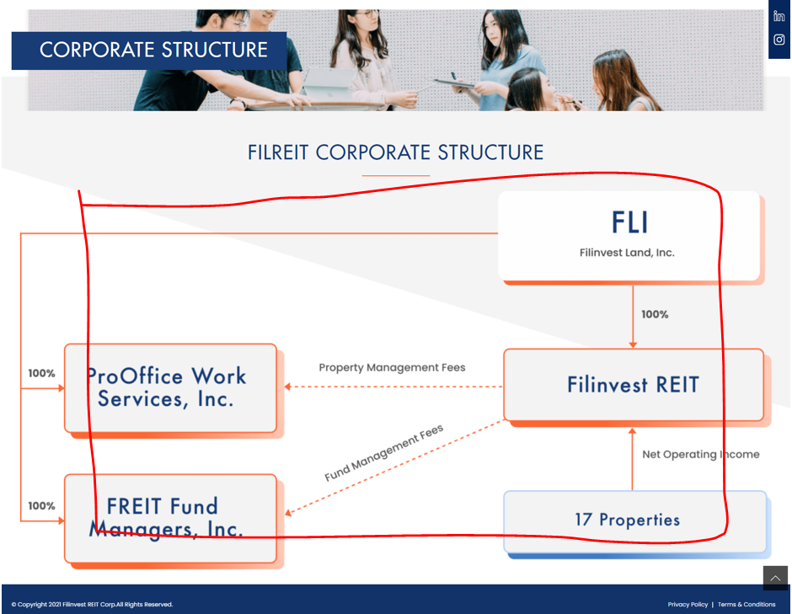

Articles of Incorporation and By Laws
Switch order
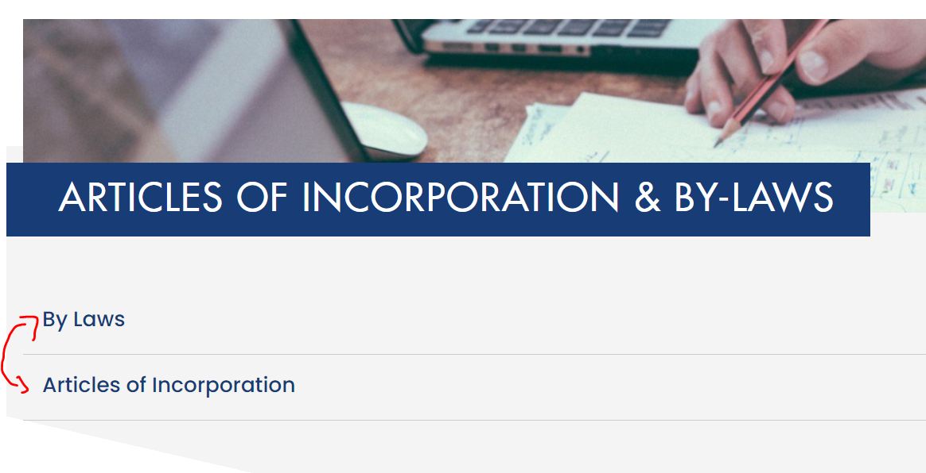

Our Tenancy
Minor edit

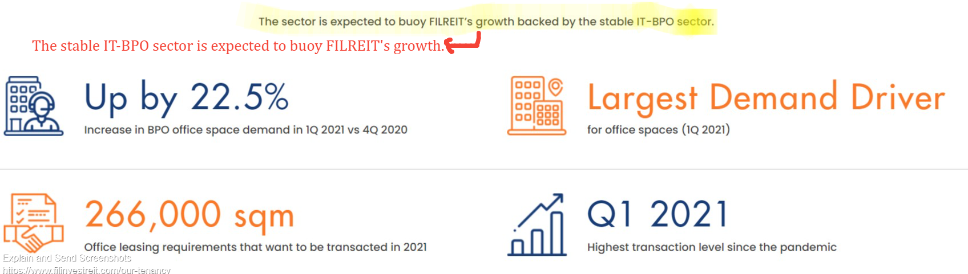

Reconfigure menu / Tab arrangement

Change “Our Projects” to “Our Business”

Subtabs and Sub-subtabs:

Our Tenancy
Our Projects
Northgate Cyberzone
Filinvest Cyberzone Cebu
Take a Tour

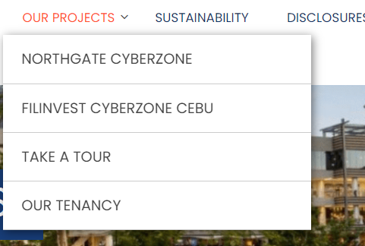

Main tabs:
- Rename ‘Corporate Governance’ to ‘Governance’
- Rename ‘Company News’ to News
  - Give News 2 subtabs: Company News; Press Releases
- Move contact us to the footer and add ‘mail’ icon on the sidebar (where the soc med icons are) which leads to the contact us page
- Compress remaining menu items so that they become one line only (Our Company, Our Projects, Sustainability, Disclosures, Governance, Investor Relations, News, REIT Education)

News
Can we add a section: Video Features
Then this will house all videos related to FILREIT (pls use order: chronological with latest on top)
Video 1:
Title: Market Edge with FILREIT Chairman Josephine Gotianun Yap
Featured on: ANC Market Edge with Michelle Ong (hyperlinked)
Date: June 11, 2021
Video link:
Get here: https://www.filinvestreit.com/company-news/anc-market-edge-josephine-gotianun-yap

Video 2:
Title: Filinvest joins REIT Party
Featured on: Rappler Business Sense with Ralf Rivas (hyperlinked)
Date: July 13, 2021
Video link:
https://www.facebook.com/watch/live/?v=330817571924899&ref=watch_permalink

Video 3:
Title: Green REIT: Investing in the Future
Featured on: Philippine Star with Danie Laurel (hyperlinked)
Date: July 30, 2021
Video link:
https://www.facebook.com/PhilippineSTAR/videos/521142542491370

Video 4:
Title: Insight with FILREIT Chairman Josephine Gotianun-Yap on PH REIT market
Featured on: ANC Insight with April Lee Tan
Date: Aug 1, 2021
Video link:
https://www.facebook.com/watch/live/?v=330817571924899&ref=watch_permalink

Committees and Members
Fix Menu, doesn’t look good like this that its broken into 2 lines, should just be one line only
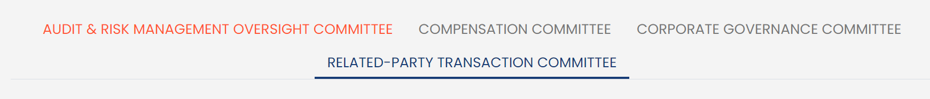
- Maybe use icons?
Have the chairman appear first on all committees
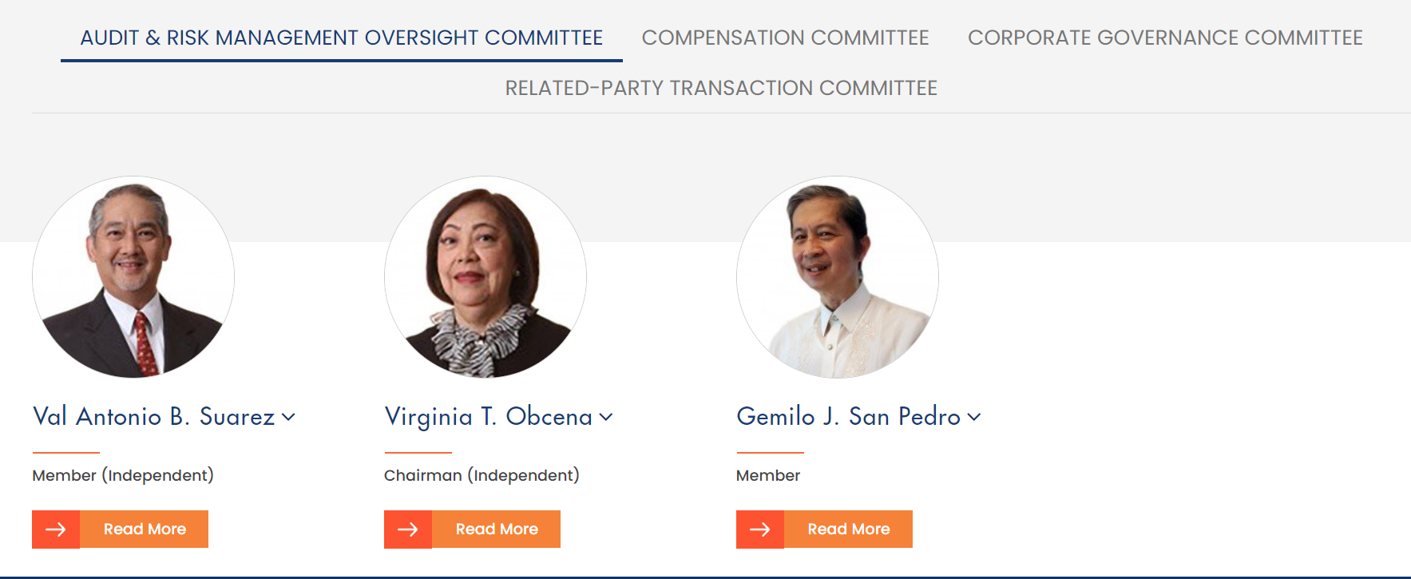
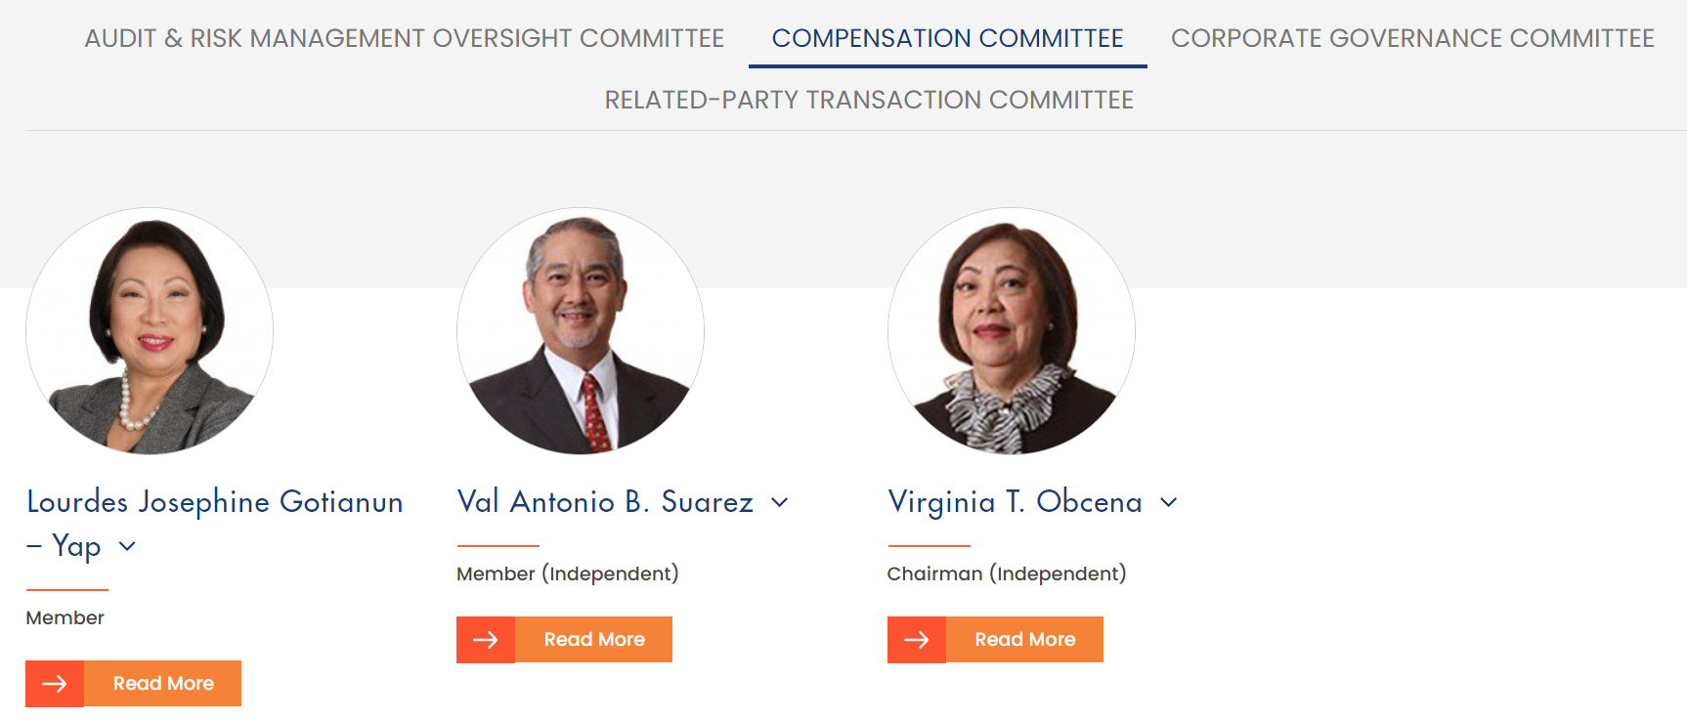
Note: Compensation Committee: Suarez should be chairman, Obcena is a Member. Remove ‘Lourdes’ from Yap’s name
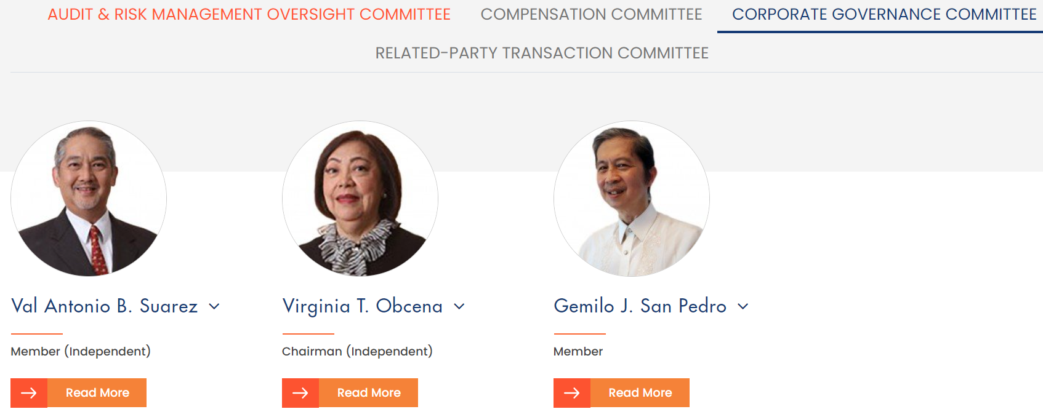
Note: Corp Governance Committee: Suarez should be Chairman, Obcena is just a member
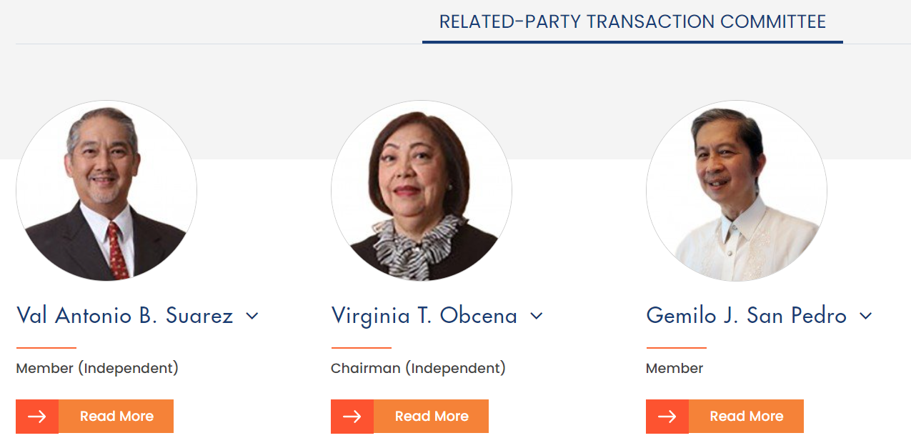

REIT Education
Embed this video here before item 1: https://www.youtube.com/watch?v=Y_XEsnzUvy4&ab_channel=Rappler

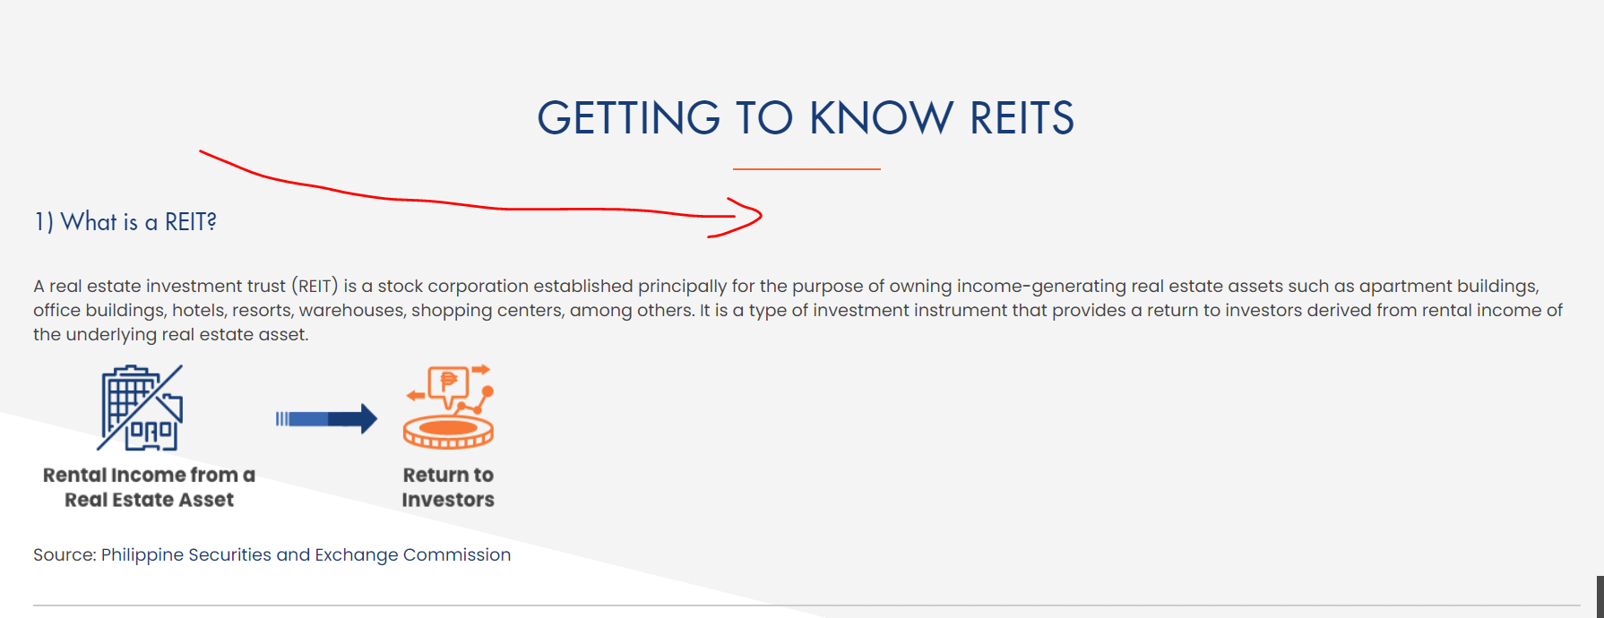

Contact Us
Reconfigure design so that the tickboxes look like they are part of the form

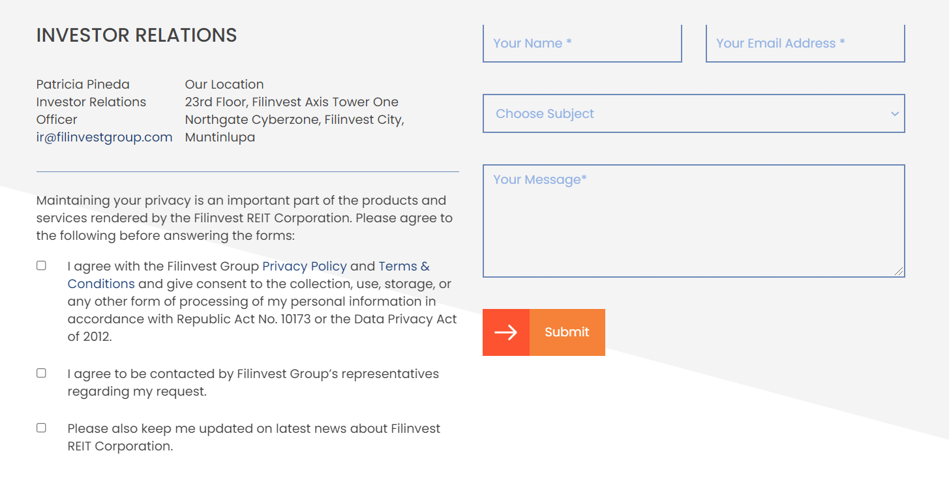
See reco below:
Send us a message
(Form here)
Maintaining your privacy is an important part of the products and services rendered by the Filinvest REIT Corporation. Please agree to the following before answering the forms:
(tickboxes)
I agree with the Filinvest Group Privacy Policy and Terms & Conditions and give consent to the collection, use, storage, or any other form of processing of my personal information in accordance with Republic Act No. 10173 or the Data Privacy Act of 2012.
I agree to be contacted by Filinvest Group’s representatives regarding my request.
Please also keep me updated on latest news about Filinvest REIT Corporation.
(SUBMIT BUTTON)

Get in touch with us
Investor Relations
Patricia Pineda
Investor Relations Officer
ir@filinvestgroup.com

Filinvest REIT Corp.
23rd Floor, Filinvest Axis Tower One Northgate Cyberzone, Filinvest City, Muntinlupa
(Google map below)

In the sitemap, we were supposed to have a ‘Gallery’ tab which will house photos (event albums), speeches and presentations (downloadables), and videos. Can we still develop this?

